Julie Gagnon

Unit Planning with Cues

Unit Title: S’outiller contre l’insécurité linguistique | Subject area(s): Français langue seconde | Grade: 7 FI | Number of Lessons: 8

Connecting with my learners
Rationale

- Recently, I have heard a lot of francophones outside Quebec speak up about linguistic insecurity and the harm some Quebecois are doing to their confidence and their identity. I thought that it was a relevant subject to bring into class because it both touches on the language, the culture and the history of francophone communities across Canada.
- I am designing this unit thinking about what I would like them to know before reaching an age where they are too ashamed of speaking French. I read a lot about linguistic insecurity in the last couple of months and it is a real concern as a future French Immersion teacher. I think that they need to be aware of this phenomenon even before it hits them. It will give them power over it, and I hope this unit will give them the tools to fight it. One of the ways my students can fight the linguistic insecurity is also by increasing their abilities in French. So I thought it would be a good idea to not just talking about this matter but also to work on the subject while practising their French through authentic tasks.
- When I saw that the curriculum wanted us to talk about implicit and explicit in text, I did see a lot of value in this in relationship to conversation (learning to read non-verbal signals), but also in informational texts or argumentative texts. I find that there is a tremendous power in reading between the lines and uncover hidden meanings in that context, especially regarding the linguistic insecurity. People suffer from linguistic insecurity because they are told implicitly that their French is not good enough, that they are not “real” francophones.
- I believe that with the right scaffolding, my students can achieve the interview and the reflection. I don’t expect them to identify implicit in each argument made in each new video or text presented to them, but I see that it is a useful way of introducing that concept in class.
Connecting with the curriculum
Core Competencies

- Communication
- Critical Thinking
- Positive personal and cultural identity
- Personal awareness and responsibility
- Social responsibility
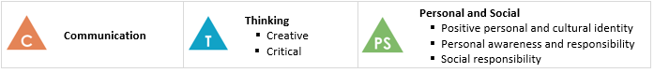
Big Ideas  - Expressing our thoughts enables us to situate ourselves in relation to our own and others’ cultures.  - Considering the feelings evoked by a message and its unspoken elements allows us to construct the meaning of a message. | Essential Questions  - What is linguistic insecurity?  - How does linguistic insecurity affect francophone communities across Canada?  - What can we do to end linguistic insecurity in a minority situation?
Learning Standards: Curricular Competencies  - Exploring and Reflecting:  - Identify verbal and non-verbal responses and adjust discourse accordingly, in order to be better understood  - Identify implicit information in a text, relying on specific cues and prior knowledge  - Identify the structure of a text to determine how it is organized and how its ideas are connected  - Creating and Communicating:  - Spontaneously support and justify own viewpoints  - Organize thoughts using the most appropriate structure for presenting one’s work  - Write clear, coherent texts, following the structures being studied  - In one’s work, revise the ideas, organization and grammar to improve the message  - Summarize the main idea in a text in a clear, well-organized manner | Learning Standards: Content  - Text organization:  - structure of informational texts  - Language elements:  - structure of the superlative  - agreement of tenses  - Revision strategies  - Communication strategies:  - verbal and non-verbal communication  - Clarification  - argumentation  - reformulation  - consideration of other people’s perspectives  - Cultural and historical elements
First Peoples Principles
- Learning requires exploration of one’s identity.
- Learning is holistic, reflexive, reflective, experiential, and relational (focused on connectedness, on reciprocal relationships, and a sense of place).
- Learning recognizes the role of indigenous knowledge. (Especially during the visit to the Museum)
- Learning is embedded in memory, history, and story.

Connecting with assessment
Formative  - Worksheets  - Implicit game  - Meme  - Tweet  - Peer interview (+ self-assessment)  - Questions for the interview  - Those opportunities of formative assessment will make sure that students understand the implicit theory, and the intricacies of linguistic insecurity. Plus, they will give them an occasion to construct and reflect on their own point of view regarding this phenomenon. | Summative  - Students will conduct a discussion with one person of the francophone community in Canada (3-5 minutes) and provide an audio, video or written transcript of it. They will add a portion to reflect on the influence (or not) of this interview on their view of linguistic insecurity.  - They will have to detail their view of linguistic insecurity in Canada and discuss it with someone. They will have to read implicit information provided by the interviewed person and they will have to be spontaneous in their answer in the conversation.
Adaptation
- They can hand in their interview and reflection in audio, video, written, or comic forms.
- They have the choice of whomù they want to interview.
- The caption will be on during the video and maybe present them at a slower pace with Youtube.
- Allow more time to complete the assignment or reduced time for the interview.
- Allow speech to text technology.

Resources
- 1st video for the introduction: https://www.youtube.com/watch?v=VqBo7-dtLJA
- List of questions for the Gradation activity (see Annex)
- 2nd video: https://www.youtube.com/watch?v=RJRz9MQTlw4
- The Meme activity with Chromebook (or Meme pictures if Chromebooks are unavailable)
- https://laclassedemallory.net/2017/04/24/jeu-sur-les-inferences-enquete-de-lecture/ (see Annex 1 for an example)
- List of ads to work with (see Annex)
- https://onfr.tfo.org/mon-accent-ton-probleme-les-accents/
- https://ici.tou.tv/denise-au-pays-des-francos
- https://ici.radio-canada.ca/tele/tout-le-monde-en-parle/site/segments/entrevue/137824/francophones-francos-canada-francais-communaute-etudes
- Twitter activity (see Annex)
- https://www.facebook.com/icicolombiebritannique/videos/375489863324361/
- https://www.cjfcb.com/activities/comite-securite-linguistique/
- https://www.acelf.ca/c/bap/tableau.php?id=1060
- https://francosphere.acelf.ca/francophonie/confiante/insecurite-linguistique-nos-jeunes-ne-malades/
- https://www.acelf.ca/c/bap/fichiers/1060_bap14_la-franco-boite-mystere.pdf
- https://www.acelf.ca/c/bap/tableau.php?id=1190
- https://www.youtube.com/watch?v=7p6WR0hTBc8
- https://royalbcmuseum.bc.ca/visit/exhibitions/our-living-languages-first-peoples-voices-bc

Classroom Management
- Routine: 10 minutes of power reading followed by a warm up activity and we always end our class with some quiet time to write in our personal dictionary or journal.
- There is always one or two activities that require movements in the classroom
- The groups will always be assigned and I will always have a seated plan with assigned seats.
- I organized a variety of activities.

Engaging in Learning Design
Lesson 1  Introduction to the new unit on linguistic insecurity through videos, discussions and activities.  Learning Intention(s):  - Introduce the concept of “Linguistic insecurity” through cultural and historical elements.  - Students will also have the opportunity to learn more about themselves and question their worldview as francophones.  Learning Standard/Core Competency Focus:  - Positive personal and cultural identity  - Personal awareness and responsibility  - Social responsibility  - Expressing our thoughts enables us to situate ourselves in relation to our own and others’ cultures.  - Spontaneously support and justify own viewpoints | - 10 minutes of power reading  - Warm up activity  - Lecture about linguistic insecurity + video and short discussion  - Gradation activity  - Videos about linguistic insecurity with jigsaw  - Meme activity  - Personal dictionary time | - I will need access to Youtube to show my videos (see the lesson plan). I will also need to make space in my room for the activities. I am thinking of a seating plan in a circle for this class (with assigned seats).  - The warm up activity, the gradation one and the jigsaw are all opportunities to reflect on their own worldview on linguistic insecurity and what it means to be francophone in Canada (and in an English-speaking province).  - This lesson is the beginning of a new unit. However I would hope that we would have previously talked about francophone culture in Canada, the history or the identity piece.
Lesson 2  Introduction to the notion of implicit and explicit in a variety of texts through activities and worksheets.  Learning Intention(s):  - Students should be able to find the implicit information in the ads presented in class.  Learning Standard/Core Competency Focus:  - Communication  - Critical Thinking  - Considering the feelings evoked by a message and its unspoken elements allow us to construct the meaning of a message.  - Identify implicit information in a text, relying on specific cues and prior knowledge  - Consideration of other people’s perspectives | - 10 minutes of power reading  - Warm up activity  - Introduction to “Implicite - explicite”  - Game  - Recap  - Find the implicit in an advertising  - Presentation of the final project  - Co-creation of the assessment rubric  - Personal dictionary time | - I will need the game and access to the internet for the advertising activity.  - There will be a time for self-assessment throughout the game and they will have the opportunity to deepen their understanding or ask questions with the recap phase and the advertising quizz.  - This lesson sets the foundation for the work with implicit and linguistic security during this unit. It presents the concept and allows students to practise and get comfortable recognizing the implicit.
Lesson 3  Tying Insecurity and Implicit together  Learning Intention(s):  - Students should start to be able to identify implicit information in a text.  - Students can find hidden meaning (implicit) in relation to linguistic insecurity with the help of questioning and scaffolding.  Learning Standard/Core Competency Focus:  - Communication  - Critical Thinking  - Considering the feelings evoked by a message and its unspoken elements allows us to construct the meaning of a message.  - Identify implicit information in a text, relying on specific cues and prior knowledge  - Consideration of other people’s perspectives | - 10 minutes of power reading  - Warm up activity  - Video Accent  - Introduction to implicit in relation to linguistic insecurity  - Clips from documentary “Denise au pays des francos”  - Tweet activity  - Personal dictionary time  - Exit ticket: For my final project, I want to interview X because Y. | - I will need the internet to show my videos.  - I will need Chromebooks for the Twitter activity.  - This lesson will allow for reflection with the Tweet activity. It will also provide feedback and assessment with the rubric.  - The exit ticket will ensure that the students are on track with their final assessment and that I can provide suggestions or comments before they begin to work.  - This lesson is starting to tie together the previous notions we learned in the first two lessons. It also implements a first reflection of finding hidden meaning of linguistic insecurity.
Lesson 4  Practise interview  Learning Intention(s):  - Students should be able to create a short interview with a pair.  - Students should also be able to reflect on their own performance with the help of an assessment rubric.  Learning Standard/Core Competency Focus:  - Structure of the superlative  - Agreement of tenses  - Revision strategies  - Communication strategies:  - Verbal and non-verbal communication  - Clarification  - Argumentation  - Reformulation  - Revision strategies  - Consideration of other people’s perspectives  - Identify verbal and non-verbal responses and adjust discourse accordingly, in order to be better understood  - Spontaneously support and justify own viewpoints  - Organize thoughts using the most appropriate structure for presenting one’s work  - Write clear, coherent texts, following the structures being studied | - 10 minutes of power reading  - Warm up activity  - Notions on interview techniques  - Revision on the question (gram  - Practice interview in pairs with the rubric created earlier this unit (recorded with the help of an iPad)  - Introduction to self-assessment of their performance (model and explained).  - Self-assessment  - Preparation for the conference  - Personal dictionary time | - Preparation for the conference: https://www.facebook.com/icicolombiebritannique/videos/375489863324361/  - This lesson is going to help students work on the interview part of their final assessment: questioning, interview techniques, a practice and a self-assessment.  - They will have the opportunity of listening themselves interview each other and will provide a self-assessment based on the same rubric I will use for the final assessment. It won’t be for a grade, but I will collect them to read them.  - This lesson is also just before a conference on linguistic security given by the Conseil jeunesse francophone de la Colombie-Britannique. I want to take a moment to prepare the students and ask them to create 2 or 3 questions to ask.
Lesson 5  Conference with the Linguistic Security Committee’s member of the Conseil Jeunesse de la Colombie-Britannique.  Learning Intention(s):  - Students should be able to ask questions related to the Linguistic Security.  - Students should also be able to demonstrate their understanding of the concept and the conference through an exit ticket (3 things and 1 wish).  Learning Standard/Core Competency Focus:  - Summarize the main idea in a text in a clear, well-organized manner  - Spontaneously support and justify own viewpoints  - Consideration of other people’s perspectives  - Cultural and historical elements  - Expressing our thoughts enables us to situate ourselves in relation to our own and others’ cultures.  - Considering the feelings evoked by a message and its unspoken elements allow us to construct the meaning of a message. | - 10 minutes of power reading  - Warm up activity  - Conference and discussion (1 hour)  - Write 5 questions to ask in the final assessment.  - Personal dictionary time  - Exit ticket : 3 things I learned and 1 wish to learn | - https://www.cjfcb.com/activities/comite-securite-linguistique/  - This lesson is an opportunity for my students to live an authentic discussion with someone who is raising awareness around linguistic insecurity. I believe they also have some workshops prepared for the students.  - Based on the work we did last lesson, the students will create 5 questions to ask for their final assessment. I will review this with comments.  - They will also provide an exit ticket as an opportunity to reflect on the conference presented in class.  - This lesson is a great opportunity to reflect on that subject, on their identity, connect with a role model and work on their questions.
Lesson 6  Their francophone identity  Learning Intention(s):  - Students should reflect on their francophone identity by representing it with an object and explain why they picked it.  Learning Standard/Core Competency Focus:  - Expressing our thoughts enables us to situate ourselves in relation to our own and others’ cultures.  - Organize thoughts using the most appropriate structure for presenting one’s work  - Write clear, coherent texts, following the structures being studied  - Cultural and historical elements | - 10 minutes of power reading  - Warm up activity  - A little bit of history (francophones in BC) with ACELF timeline.  - Discussion on the “extinction” of French or the dangers.  - Activity Franco-boîte mystère  - Video and start thinking about tools to prevent insecurity.  - Preparation for the exhibition “Our living language”  - Work on their final project  - Personal dictionary time | - https://www.acelf.ca/c/bap/tableau.php?id=1060  - https://francosphere.acelf.ca/francophonie/confiante/insecurite-linguistique-nos-jeunes-ne-malades/  - https://www.acelf.ca/c/bap/fichiers/1060_bap14_la-franco-boite-mystere.pdf  - https://www.acelf.ca/c/bap/tableau.php?id=1190  - Preparation for Our living language: https://www.youtube.com/watch?v=7p6WR0hTBc8  - This lesson is really based on the historical, cultural and identity components of the francophone community.I want to touch on those subjects in relation to the linguistic insecurity because language and identity go hand in hand.  - It is also a great jumping point to prepare the students to visit the exhibition “Our living languages”.  - It is also a lesson where they will have time to work on their project before the visit and the end of the unit.
Lesson 7  Visit to the Royal B.C. Museum for Our living languages exhibition  Learning Intention(s):  - Students should be able to reflect on the important link between language and identity.  - Students should also find in the testimonies about disrupted languages in BC one piece of information that will help them in their life as francophone in a minority situation.  Learning Standard/Core Competency Focus:  - Expressing our thoughts enables us to situate ourselves in relation to our own and others’ cultures.  - Considering the feelings evoked by a message and its unspoken elements allow us to construct the meaning of a message. | - Discuss how museum does also provide opportunities for keeping a memory alive (duty of memory).  - Reflect on how language and identity are linked.  - Find one tool to add to their toolbox  - Personal dictionary time | - https://royalbcmuseum.bc.ca/visit/exhibitions/our-living-languages-first-peoples-voices-bc  - This visit is intended to discuss about the duty of memory, but also our duty to keep our identity and language alive.  - It is a great reflection to continue talking about the relationship between identity and language.  - They might find one tool to prevent insecurity to add in their toolbox.
Lesson 8  Work on the interview and reflection (maybe multiple lessons)  Learning Intention(s):  - Students should be able to discuss and question a francophone about linguistic insecurities with appropriate vocabulary and responses.  - Students should be able to reflect on their experience and their identity as francophone through a self-reflection written exercise or audio recording.  Learning Standard/Core Competency Focus:  - Spontaneously support and justify own viewpoints  - Organize thoughts using the most appropriate structure for presenting one’s work  - Write clear, coherent texts, following the structures being studied in one’s work, revise the ideas, organization and grammar to improve the message  - Identify verbal and non-verbal responses and adjust discourse accordingly, in order to be better understood  - Structure of informational texts  - Structure of the superlative  - Agreement of tenses  - Revision strategies  - Verbal and non-verbal communication  - Clarification  - Reformulation  - Consideration of other people’s perspectives  - Cultural and historical elements | - 10 minutes of power reading  - Warm up activity  - Put final touches on the interviews  - Write a reflection on the process  - Personal journal time | - This lesson is one of the last few we will have with the project. It is supposed to give time for students to put the final touches on their project before handing it in.  - They will also have to reflect on that project and the effect it had on them.

Lesson 1 template

Learning Intention(s) and Assessment  - Introduce the concept of “Linguistic insecurity” through cultural and historical elements.  - Students will also have the opportunity to learn more about themselves and question their worldview as francophones.  - Assess their understanding of the linguistic insecurity through the production of a Meme related to their experience of Linguistic Insecurity | Resources  - List of questions for the warm up activity (Annex 1)  - 1st video for the introduction: https://www.youtube.com/watch?v=VqBo7-dtLJA  - List of questions for the Gradation activity (Annex 2)  - 2nd video: https://www.youtube.com/watch?v=RJRz9MQTlw4  - The Meme activity with Chromebook (or Meme pictures if Chromebooks are unavailable)
Teacher Activity  - Explain and lead the warm up activity:  Students are invited to trace an imaginary line in the class. At each opposite point of this line, I will name an item and students are invited to reach the spot that corresponds the most to their answer. They will be invited to talk exchange about it with others. I will also ask what can maybe uncomfortable questions for them. If they don’t wish to take a stand, I will suggest that they stay in the middle. If they want to take a stand, they can also find a new corner to present their answer. (See Annex 1 for questions.)  - Transition: Comme nous pouvons le voir, il y a certaines questions qui vous ont amenés vers le centre, à mi-chemin entre les deux réponses. Parce que nous sommes humains, il est difficile de penser en termes de blanc ou noir. Certaines circonstances auraient pu changer votre réponse. Peut-être que si j’avais offert une situation spécifique à certaines questions, vous auriez choisi un autre point. Et notre sujet d’aujourd’hui est tout aussi nuancé parce qu’il est vécu par des humains, par vous et par moi. Nous allons parler d’insécurité linguistique. Vous voyez, certaines personnes sont fières de parler français, mais lorsqu’elles se font corriger, elles perdent un peu de leur confiance et de leur amour du français. Parfois, certaines personnes maîtrisent très bien le français, mais ne se sentent pas confortables de le parler en public ou avec des gens dont c’est leur langue maternelle.  - Introduce the idea of linguistic insecurity through a video:  Avant même de vous présenter un vidéo sur le sujet, je voudrais savoir avec votre pouce si vous avez déjà eu peur de parler français avec quelqu’un? Qui s’est déjà fait corriger par quelqu’un et s’est senti humilié? Qui a eu l’impression que leur français n’était pas assez bon?  After the video: est-ce qu’il y a des mots qui nous ont posé problème dans cette vidéo? (Faire banque de mots et définition au tableau) A-t-on besoin de la réécouter? Sinon, comment le premier ministre du Canada se sent-il face au français? Qu’est-ce qu’on entend sur l’utilisation du français par les anglophones? Est-ce que quelqu’un peut résumer ce qu’est l’insécurité linguistique?  - Leading the gradation activity:  Same principle as the warm up activity: students will be invited to find their position on a spectrum from a “Yes” to “No” point or an “Often” to a “Never” point or a “Always” to a “Not at all” point. Then, they are going to be invited on some questions to discuss their answer with somebody or with the whole class. (see Annex 2 for questions).  Transition: Talk about how there was an interesting variety of answers. How it is very common, and how we can see similar answers in the next video.  - Present the second video.  - Leading the discussion with the video : Jigsaw - They will discuss (with the help of discussion prompts - see annex 8) in the 4 corners of the class in groups of 2-4 and move around the room until they have answered all the questions. Before moving to the next question, they will be asked to leave one word or idea on a sheet beside the question that resume their discussion:  - What is linguistic insecurity?  - What are the principal problems with linguistic insecurity?  - What are some of the examples of linguistic insecurity presented in the video?  - What could be a solution?  At the end, I will ask each group to tell us what the words or ideas are on the sheet beside their questions and add on by resuming their own discussion.  Transition: Talk about what we said should be used as an inspiration to create something to raise awareness about linguistic insecurity. We should try to communicate that information with others, the school, for example.  - Present the Meme activity:  In pairs, students will be invited to use a Meme Generator online to create a Meme related to a personal experience or an interesting information about linguistic insecurity. They will be invited to share them if they want with the whole class at the end of the activity. They would also be invited to put them on a board outside the class to raise awareness in the whole school. | Student Activity  - 10 minutes of power reading  - Warm up activity  - Listen the lecture about linguistic insecurity  - Gradation activity  - Listen to the videos about linguistic insecurity with discussion  - Jigsaw activity  - Meme activity  - Personal dictionary time: students are asked to contribute daily to their personal dictionary by adding new words, rules or expressions they learned along with a definition. If they do not have a new contribution, they may use that time to write in their personal journals.
My Reflection | Next Steps  - I will use the thumb on the chest method to check for understanding throughout the lesson.  - I will also check for understanding with questions.  - I will need to make the relationship clear with this material and the next (implicit and explicit information).  - I will need to recap linguistic insecurity at the beginning of the next lesson and before explaining the assignment.

Lesson 2 template

Learning Intention(s) and Assessment  Introduction to the notion of implicit and explicit in a variety of texts through activities and worksheets.  - Students should be able to find the implicit information in the ads presented in class.  - Student understanding will be assessed throughout the lesson with the help of two games. | Resources  - https://laclassedemallory.net/2017/04/24/jeu-sur-les-inferences-enquete-de-lecture/ (see Annex 4 for an example)  - List of ads to work with (see Annex 5)
Teacher Activity  - Warm up activity: I will stick on each of their back a name of a well-known character (real or fictional) and they will need to find out who they are by asking questions a maximum of 2 questions per person. They will need to keep their name because they will find their partner for the game with this name. During this activity, I will note different questions or answers that implies something for the next step. (see Annex 3)  - Introduction of the implicit and explicit by linking it to the warm up activity (how questions or answers do sometimes imply something).  - Play the game of implicit in pairs. They will find their partner through the name they got. For example: Mickey and Minnie Mouse, Shrek and Fiona, Justin and Hailey Bieber. They will have to roll a dice, find the card associated with the number they landed on and find the implicit information on the card. Both of them need to reach the end of the game to be over.  - Recap what we learned about the implicit and explicit so far. Find a rule or rules together.  - I will present printed or televised ads and I will ask the whole class to find the implicit message in each one of them. I will make sure to talk about how implicit can be found everywhere, especially in conversation like we saw in the warm up activity. The assessment won’t have an implicit criteria, but it will help them have genuine and spontaneous conversation if they understand the implicit.  - I will present the final assessment:  - It is an interview of 3 to 5 minutes.  - They need to find a francophone to interview (parents, friends, or I can help find them). They will communicate this information with an exit ticket on lesson 3.  - They will need to prepare a list of questions beforehand which we will be assessed and comments will be provided.  - They will need to record the interview whether it is with a camera, a voice recorder. They can hand in a written transcript if they don’t feel comfortable with their voice or image.  - They will need to use a language that is free of errors.  - We will co-create the assessment rubric  - They can spend time on their personal dictionary or journal. | Student Activity  - 10 minutes of power reading  - Warm up activity  - Listen to the introduction of the new terms: implicit and explicit.  - Game  - Contribute to the recap  - Find the implicit in an advertising  - Listen to the presentation of the final project  - Co-creation of the rubric  - Personal dictionary time
My Reflection | Next Steps  - Next step will be to tie the first two lessons together so the students can understand how finding the implicit meaning can make them comprehend the linguistic insecurity.  - I will need to do both a recap of what we learned about linguistic insecurity AND the implicit.  - The questioning techniques used in the warm up activity might be a useful resource for them in the interview part of their assessment.

Lesson 3 template

Learning Intention(s) and Assessment  Tying Insecurity and Implicit together  - Students should start to be able to identify implicit information in a text.  - Students can find hidden meaning (implicit) in relation to linguistic insecurity with the help of questioning and scaffolding.  - Student understanding will be assessed through the tweet activity.  - I will also use the exit ticket to review their project idea and add comments or suggestions if I need to. | Resources  - https://onfr.tfo.org/mon-accent-ton-probleme-les-accents/  - https://ici.tou.tv/denise-au-pays-des-francos  - https://ici.radio-canada.ca/tele/tout-le-monde-en-parle/site/segments/entrevue/137824/francophones-francos-canada-francais-communaute-etudes  - Twitter activity (see Annex 6) and assessment rubric (Annex 7)
Teacher Activity  - Warm up activity: When entering the class, they will be asked to pick an emoji that represent their feelings toward being francophone. I will ask each one of them to share about it in the class. They will have the possibility to pass if they don’t feel comfortable, but they will have to write it. (Annex 9)  Transition: Talk about how we are going to start reflecting on how we feel about being francophone and linguistic insecurity. I will present a video that will illustrate the implicit in action in that specific context.  - Introduce the TFO video about accents and how the implicit affect those people. Informal class discussion about what types of feeling it provokes in them? Did they live a similar situation? What is the implicit here?  - Introduction to implicit in argumentation: how hidden meaning in one’s argument can have an effect on someone or the debate.  - Tweet activity: We will watch parts of Denise Bombardier’s most recent documentary and then watch an interview of francophones living outside of Quebec reacting to her statements. I will ask the students to think about their view on this matter and discuss it in groups. Then, I will ask them to write a tweet on the subject. The tweet should be no more than 280 characters, include a link or a retweet, and contain at least one hashtag. It should be concise, respectful and reflecting their personal opinion. It should also be free of language errors.  - I will ask some students to present them if they want. We could put them on the document camera. They could even put them on a board outside the class.  - They are invited to write in their dictionary or journal.  - Before leaving, they will have to give me an exit ticket: they will have to state shortly whom they want to interview and why in one sentence. In the “why” section, I need to know how they are related to this question, how they are relevant to the subject of linguistic insecurity. It will give me an opportunity to check on students to make sure they are on the right track. I won’t give any points for this, but I will comment on it if I need to. | Student Activity  - 10 minutes of power reading  - Warm up activity  - TFO video  - Introduction to implicit in argumentation  - Tweet activity (see Annex 6)  - Personal dictionary time  - Exit ticket: For my final project, I want to interview X because Y.
My Reflection | Next Steps  - The next steps will be to find their personal identity and opinion through all of the information about linguistic insecurity and its impact on francophones.  - The next lesson will be about the interview (and the final assessment). The challenge will be to bring all of this reflection and information in a more concrete, and useful way.

Annex 1
Questions for warm up activity in lesson 1
- Je préfère les chats ou les chiens.
- J’aime les sports ou l’art.
- J’écoute de la musique rock ou pop.
- Je me considère introvertie ou extravertie.
- Français ou Anglais?
- C’est de ma faute ou c’est de la faute de l’autre.
- Je doute de moi ou je suis confiant-e.
- Netflix ou saut en bungee..
- Prendre des risques ou choisir la sécurité.
- Je m’exprime ou je reste silencieux-se.
Annex 2
Questions for gradation activity in lesson 1
- Souvent ou Jamais : Je ne me sens pas à l’aise de parler français.
- “ “ : Je parle français avec mes ami-e-s.
- “ “ : Quand quelqu’un me corrige, je me sens gêné-e.
- “ “ : Quand je parle avec un ou une francophone, j’ai peur de faire des erreurs.
- “ “ : J’utilise l’anglais dans mes phrases en français.
- Oui ou non: Je pense que mon français n’est pas assez bon.
- “ “ : Je pense que j’ai besoin d’avoir un français parfait.
- “ “ : Le français est plus difficile que l’anglais.
- “ “ : Je ne pourrais jamais vivre en français.
- “ “ : Je ne me considère pas francophone.
Annex 3
Warm up activity names for lesson 2
- Kim Kardashian et Kanye West
- Minnie et Mickey Mouse
- Hailey et Justin Bieber
- Shrek et Fiona
- Winnie The Pooh et Christopher Robin
- Mario et Luigi
- Bob l’éponge carrée et Patrick
- Batman et Robin
- Barbie et Ken
- Harry Potter et Hermione Granger

Annex 4
Cards for the implicit game
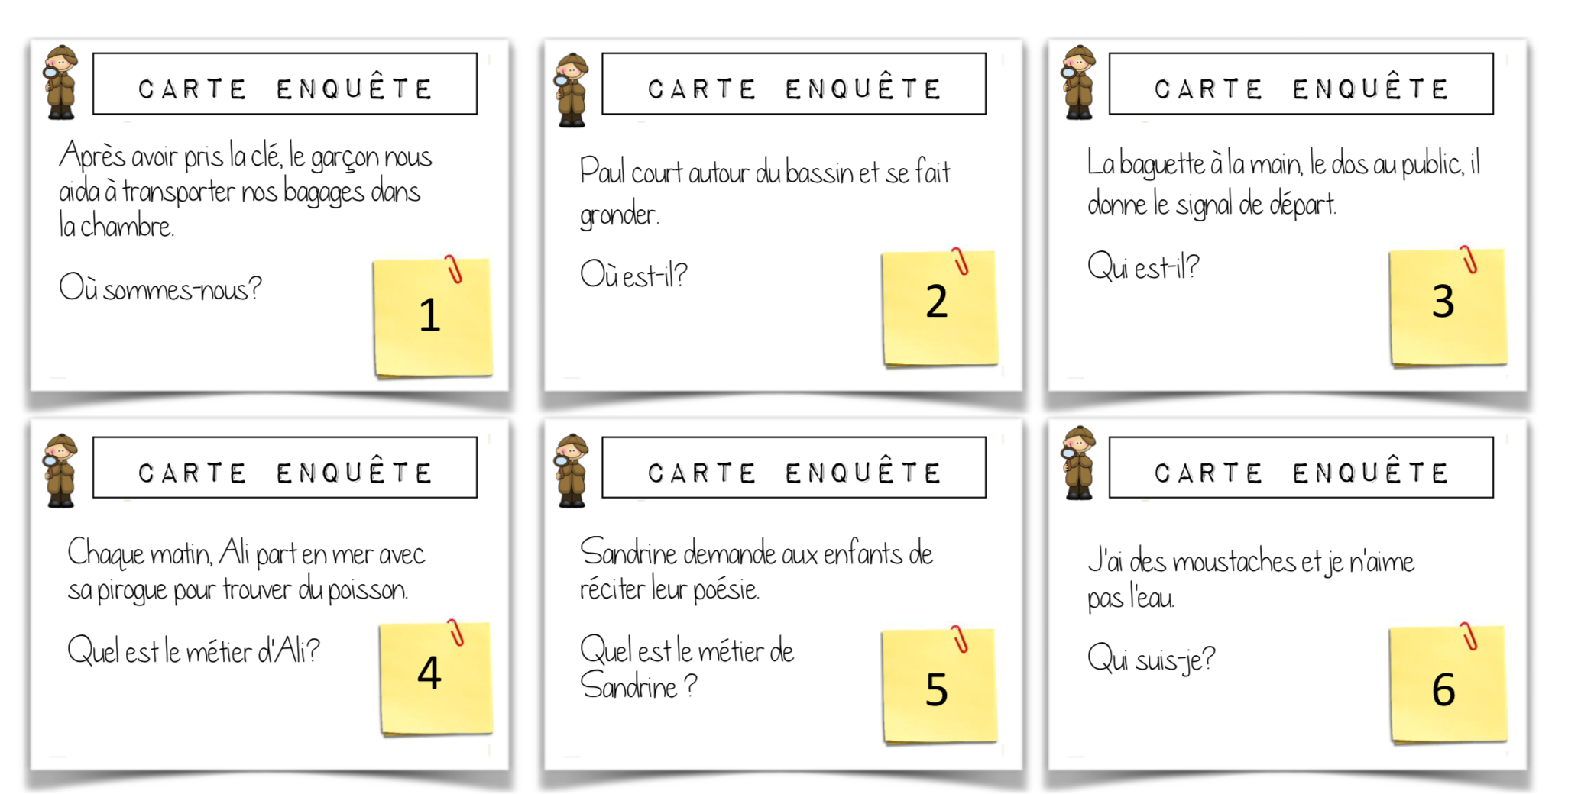

Annex 5
Ad list:
- https://www.youtube.com/watch?v=GpIIeNI0Bqw
- https://www.youtube.com/watch?v=kES_DYFcAQ0
- https://www.youtube.com/watch?v=kGAl1-C3_d4



- 
Annex 6
Tweet sheet for the students
Name:
(Max 280 characters including spaces)

Annex 7
Updated assessment rubric
Respect of the instructions | 280 characters or less | /3
 | Including a link or a retweet
 | One hashtag
Presentation | Respectful | /3
 | Show their opinion (Je pense, Je crois, etc.)
Language | Free of language errors | /3
Total /9

Annex 8
Carte de communication - par l’école intermédiaire Central
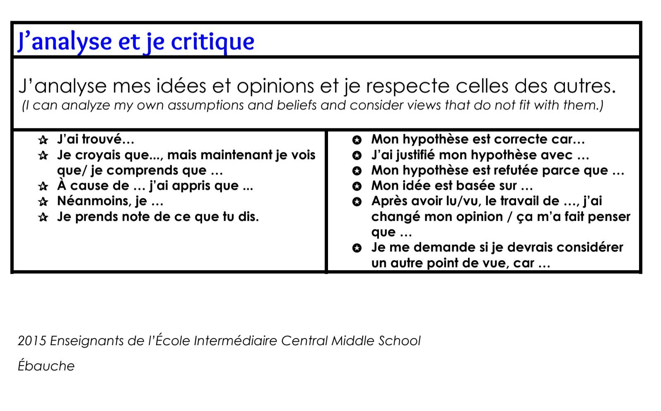
Annex 9
Warm up activity emojis (I would maybe not use a couple of them, but this is an example)


